Hive Join
https://data-flair.training/blogs/hive-join/
Basically, for combining specific fields from two tables by using values common to each one we use Hive JOIN clause. In other words, to combine records from two or more tables in the database we use JOIN clause. However, it is more or less similar to SQL JOIN. Also, we use it to combine rows from multiple tables.
Moreover, there are some points we need to observe about Hive Join:
- In Joins, only Equality joins are allowed.
- However, in the same query more than two tables can be joined.
- Basically, to offer more control over ON Clause for which there is no match LEFT, RIGHT, FULL OUTER joins exist in order.
- Also, note that Hive Joins are not Commutative
- Whether they are LEFT or RIGHT joins in Hive, even then Joins are left-associative.

Apache Hive Join Syntax
Following is a syntax of Hive Join – HiveQL Select Clause.
join_table:
table_reference JOIN table_factor [join_condition]
| table_reference {LEFT|RIGHT|FULL} [OUTER] JOIN table_reference
join_condition
| table_reference LEFT SEMI JOIN table_reference join_condition
| table_reference CROSS JOIN table_reference [join_condition]

Type of Joins in Hive
Basically, there are 4 types of Hive Join. Such as:
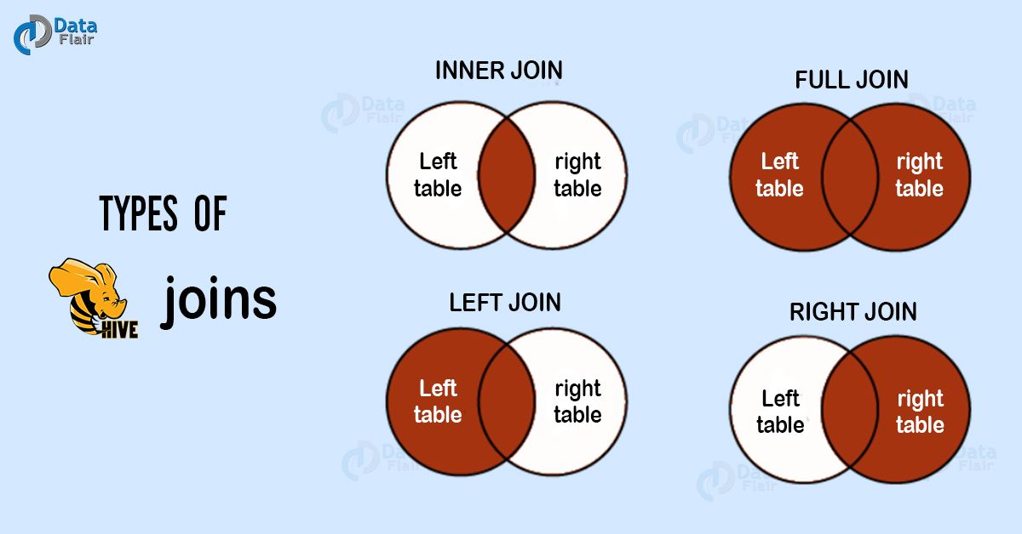

Example of Hive Join – HiveQL Select Clause.
However, to understand well let’s suppose the following table named CUSTOMERS.
ID | Name | Age | Address | Salary
1 | Ross | 32 | Ahmedabad | 2000
2 | Rachel | 25 | Delhi | 1500
3 | Chandler | 23 | Kota | 2000
4 | Monika | 25 | Mumbai | 6500
5 | Mike | 27 | Bhopal | 8500
6 | Phoebe | 22 | MP | 4500
7 | Joey | 24 | Indore | 10000
Also, suppose another table ORDERS as follows:
OID | Date | Customer_ID | Amount
102 | 2016-10-08 00:00:00 | 3 | 3000
100 | 2016-10-08 00:00:00 | 3 | 1500
101 | 2016-11-20 00:00:00 | 2 | 1560
103 | 2015-05-20 00:00:00 | 4 | 2060

Inner Join
Basically, to combine and retrieve the records from multiple tables we use Hive Join clause. Moreover, in SQL JOIN is as same as OUTER JOIN. Moreover, by using the primary keys and foreign keys of the tables JOIN condition is to be raised.
Furthermore, the below query executes JOIN the CUSTOMER and ORDER tables. Then further retrieves the records:
SELECT c.ID, c.NAME, c.AGE, o.AMOUNT
FROM CUSTOMERS c JOIN ORDERS o
ON (c.ID = o.CUSTOMER_ID);
Moreover, we get to see the following response, on the successful execution of the query:
ID | Name | Age | Amount
3 | Chandler | 23 | 1300
3 | Chandler | 23 | 1500
2 | Rachel | 25 | 1560
4 | Monika

Left Outer Join
On defining HiveQL Left Outer Join, even if there are no matches in the right table it returns all the rows from the left table. To be more specific, even if the ON clause matches 0 (zero) records in the right table, then also this Hive JOIN still returns a row in the result. Although, it returns with NULL in each column from the right table.
In addition, it returns all the values from the left table. Also, the matched values from the right table, or NULL in case of no matching JOIN predicate.
However, the below query shows LEFT OUTER JOIN between CUSTOMER as well as ORDER tables:
SELECT c.ID, c.NAME, o.AMOUNT, o.DATE
FROM CUSTOMERS c
LEFT OUTER JOIN ORDERS o
ON (c.ID = o.CUSTOMER_ID);
Moreover, we get to see the following response, on the successful execution of the HiveQL Select query:
ID | Name | Amount | Date
1 | Ross | NULL | NULL
2 | Rachel | 1560 | 2016-11-20 00:00:00
3 | Chandler | 3000 | 2016-10-08 00:00:00
3 | Chandler | 1500 | 2016-10-08 00:00:00
4 | Monika | 2060 | 2015-05-20 00:00:00
5 | Mike | NULL | NULL
6 | Phoebe | NULL | NULL
7 | Joey | NULL | NULL

Right Outer Join
Basically, even if there are no matches in the left table, HiveQL Right Outer Join returns all the rows from the right table. To be more specific, even if the ON clause matches 0 (zero) records in the left table, then also this Hive JOIN still returns a row in the result. Although, it returns with NULL in each column from the left table
In addition, it returns all the values from the right table. Also, the matched values from the left table or NULL in case of no matching join predicate.
However, the below query shows RIGHT OUTER JOIN between the CUSTOMER as well as ORDER tables
SELECT c.ID, c.NAME, o.AMOUNT, o.DATE FROM CUSTOMERS c RIGHT OUTER JOIN ORDERS o ON (c.ID = o.CUSTOMER_ID);

Moreover, we get to see the following response, on the successful execution of the HiveQL Select query:
ID | Name | Amount | Date
3 | Chandler | 1300 | 2016-10-08 00:00:00
3 | Chandler | 1500 | 2016-10-08 00:00:00
2 | Rachel | 1560 | 2016-11-20 00:00:00
4 | Monika | 2060 | 2015-05-20 00:00:00

Full Outer Join
The major purpose of this HiveQL Full outer Join is it combines the records of both the left and the right outer tables which fulfills the Hive JOIN condition. Moreover, this joined table contains either all the records from both the tables or fills in NULL values for missing matches on either side.
However, the below query shows FULL OUTER JOIN between CUSTOMER as well as ORDER tables:
SELECT c.ID, c.NAME, o.AMOUNT, o.DATE
FROM CUSTOMERS c
FULL OUTER JOIN ORDERS o
ON (c.ID = o.CUSTOMER_ID);

Moreover, we get to see the following response, on the successful execution of the query:
ID | Name | Amount | Date
1 | Ross | NULL | NULL
2 | Rachel | 1560 | 2016-11-20 00:00:00
3 | Chandler | 3000 | 2016-10-08 00:00:00
3 | Chandler | 1500 | 2016-10-08 00:00:00
4 | Monika | 2060 | 2015-05-20 00:00:00
5 | Mike | NULL | NULL
6 | Phoebe | NULL | NULL
7 | Joey | NULL | NULL
3 | Chandler | 3000 | 2016-10-08 00:00:00
3 | Chandler | 1500 | 2016-10-08 00:00:00
2 | Rachel | 1560 | 2016-11-20 00:00:00
4 | Monika | 2060 | 2015-05-20 00:00:00

